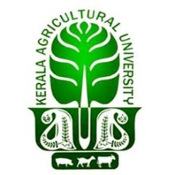
KVK/3/2025-26 Date: 14.05.2025

NOTIFICATION- ASSISTANT PROFESSOR/SUBJECT MATTER SPECIALIST (DAILY WAGE BASIS)
Applications are invited from eligible candidates for the selection as Assistant Professor/Subject Matter Specialist (SMS) on daily wage basis in the vacant posts of following disciplines at Krishi Vigyan Kendra, Kannur.
Sl. No | Discipline | Number of Posts
 | Agronomy | 1
 | Animal Husbandry | 1
Eligibility:
- Agronomy: The candidate must possess bachelor’s degree in agriculture / horticulture, master’s degree in Agronomy with a minimum of 55% marks or equivalent OGPA and have qualified NET.
- Animal Husbandry: The candidate must possess bachelor’s degree in animal husbandry, master’s degree in Livestock Production Management/ Animal Reproduction, Gynecology and Obstetrics/Veterinary Clinical Medicine with a minimum of 55% marks or equivalent OGPA and have qualified NET.
- Candidates with Ph.D in concerned disciplines will be given due weightage in selection process.
- The maximum age limit is 40 years as on 01-01-2025. Age relaxation as per existing Government will be granted to eligible candidates.
Terms & Conditions:
- The posting will be purely temporary basis for a period of 59 days or till the date of permanent / contractual appointment, whichever is earlier.
- The Station / University reserves the right to terminate the services of the appointee, if performance is found unsatisfactory or any defects are noticed.
- Candidates will not be eligible for any TA/DA for attending the interview or any other selection process.

Selection Procedure:
- Interested eligible candidates should apply by sending their resume in the attached format to kvkkannur@kau.in before 22.05.2025
- For any further queries in this regard, the candidates may contact 8547675124 between 10 am and 5pm on working days.

Programme Co-ordinator
KVK Kannur

